

**Natural Resources**

* **Natural resources** are substances found in nature which can be used by human beings to fulfil their necessities.
* The biosphere is the region of the Earth where the lithosphere, hydrosphere and atmosphere interact, making life on Earth possible.

|  |  |
| --- | --- |
| **Physical Divisions of the**  **Biosphere** | **Description** |
| **Lithosphere** | * Outer crust of the Earth. * Also known as land. * Its upper weathered part forms soil. |
| **Hydrosphere** | * Water component of the Earth—water present on the Earth’s surface and underground. * 75% of the Earth’s surface is occupied by water. |
| **Atmosphere** | * Blanket of air which covers the Earth is called the   atmosphere. |



Abiotic

Components

(Air, Water, Land)

Biotic

Components

(Living Organisms

Biosphere

# Air

* **Air** is a mixture of gases such as nitrogen, oxygen, carbon dioxide, other gases and water vapour.



Eukaryotes and prokaryotes use oxygen to break down glucose and release carbon dioxide.



Human activities such as combustion of coal and burning of fuel use oxygen and release carbon dioxide.

The amount of carbon dioxide in the atmosphere is very low and it is maintained in two ways:



Green plants convert carbon dioxide into glucose in the presence of sunlight.



Marine animals use carbonates dissolved in seawater to make their shells.

## Significance of the Atmosphere

### Role of the Atmosphere in Climate Control

* + Air is a bad conductor of heat.
  + It keeps the average temperature of the Earth steady during the day and throughout the whole year.
  + The atmosphere prevents sudden increase in temperature during daylight hours.
  + During the night, the atmosphere slows down the escape of heat into space.
  + The Moon does not have an atmosphere. The temperature on the Moon ranges between –190°C and 110°C. In the daytime, the temperature rises to 110°C, and at night, it cools down to −190°C.

### Winds: Movement of Air

* + The movement of air from one region to another creates wind.

***Air Movement in Coastal Areas***

* In daytime, there is a regular flow of cool air from the sea towards the land, while during the night, air starts flowing from the land towards the sea.

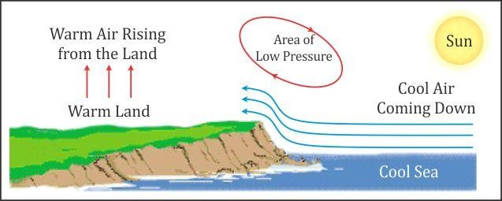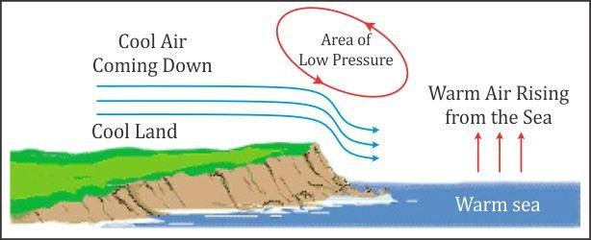

**During Day During Night**

***Wind Belts***

* Temperature differences across the Earth develop major **wind belts**.
* These wind belts define the climate zones of the world.

***Factors Influencing Movements of Air***

|  |
| --- |
| 1. Uneven heating of land at different regions of the Earth |
| 2. Differences in heating and cooling of land and water bodies |
| 3. Vaporisation and condensation of water vapour |
| 4. Rotation of the Earth |
| 5. Presence of mountain ranges in the path of wind |
| 6. Differences in topography over which wind passes |

1. **Rain**
   * A large amount of water evaporates into the air when the water bodies get heated because of solar radiations.
   * The air carrying water vapour gets heated and rises, expands and cools forming clouds.
   * As more condensation occurs, the droplets grow and become heavy, and they fall in the form of rain.
   * When the temperature of air is very low, precipitation occurs in the form of snow, hail or sleet.

***Rainfall Pattern***

* Prevailing wind patterns decide rainfall patterns.
* In large parts of India, the rainfall is brought by the south-west or north-east monsoons.

### Air Pollution

***Sources***



**Natural Sources**

**Deforestation**

**Automobile Exhausts**

**Domestic Waste**

**Sources of Air Pollution**

**Industrial Exhausts**

**Radioactive Waste**

**Mining Activities**

**Burning Fossil Fuels**

**Some Major Pollutants**

Sulphur dioxide

Nitrogen dioxide

Air Pollutants

Chlorofluoro carbon

Carbon

monoxide

**Effects of Air Pollution**



Oxides of sulphur and nitrogen react with rain water and result in acid rain.

Suspended particles of pollutants react with heat and sunlight causing low visibility,

i.e. smog.

Increased concentration of greenhouse gases such as CO2 in the atmosphere

prevents escape of heat from the Earth into space leading to global warming.

Release of CFC through air conditioners and refrigerators causes ozone depletion

which may cause skin cancer and skin diseases.



16 September is celebrated as ‘International Ozone Day’.



In 1952, approximately 12,000 people died in the London smog episode.

**Prevention of Air Pollution**

|  |
| --- |
| * Minimise the use of fuels such as petrol and diesel. Use a cleaner source such as   compressed natural gas (CNG). |
| * Regular emission testing for vehicles (e.g. PUC test for automobiles). |
| * Industries must have tall chimneys with electrostatic precipitators and filters. |
| * Garbage and plastics should not be burnt. |
| * Nuclear wastes should be disposed of safely. |
| * Fines and penalties should be enforced for those who break laws amended to control   air pollution. |

**Water**

Water is inexhaustible and the most important resource on the Earth.

## Forms of Water

**Water vapour** in the atmosphere

**Saline water** found in seas and oceans

**Fresh water** found in frozen ice caps and glaciers, rivers, lakes, streams, ponds

and groundwater

**Surface water** found in rivers, lakes, streams and ponds

* When rain falls, water percolates into the ground through soil particles which is called **groundwater**.

## Significance of Water

Water is essential for the maintenance of life.

It plays an important role in the formation of soil.

It is a living medium for many organisms.

Humans use water for drinking, washing utensils and clothes, sewage disposal, agriculture etc.

All cellular processes and metabolic reactions require water.

Water is the medium through which substances are transported within the body.

**Water Pollution**

**Water pollution** is the contamination of water sources such as rivers, lakes, oceans and groundwater.

***Sources of Water Pollution***



**Household**

**Detergents**

**Thermal**

**Pollution**

**Sewage**

**Fertilisers,**

**Pesticides, Herbicides**

**Sources**

**of Water Pollution**

**Industrial**

**Waste**

**Oil Spills in**

**Oceans**

**Domestic**

**Waste**

***Effects of Water Pollution***



Polluted water becomes unsuitable for drinking and for other uses.

Toxic substances enter the food chains and get concentrated at each successive trophic level in the food chain. This is called biomagnification.

Sewage carries disease-producing microorganisms which may cause water borne

diseases such as cholera, dysentery, jaundice, typhoid, diarrhoea etc.

Microorganisms present in polluted water depletes its oxygen content resulting in

the death of aquatic organisms.

Mixing of fertilisers in water sources cause algal growth called eutrophication which results in less oxygen supply to aquatic organisms resulting in their death.

Oil spills result in choking of the respiratory system of organisms causing their death.

***Prevention of Water Pollution***

|  |
| --- |
| Sewage, industrial waste and domestic waste should be treated to make them harmless  before they are released into water bodies. |
| Use of chemical pesticides must be minimised. |
| Use of biofertilisers should be encouraged. |
| Washing of utensils and clothes and bathing of cattle in water bodies must be avoided. |
| Garbage and other domestic waste should not be thrown in water bodies. |
| Leakage of drainage pipes must be prevented. |
| Awareness must be created among students and adults about the severity of water  pollution. |
| Laws should be formulated to control water pollution. Penalties should be enforced for those  who break the law. |

**Soil**

**Soil** is the part of the Earth’s crust which consists of disintegrated rocks and decaying organic matter. When soil loses its plant cover, it is exposed to wind and rain. It gets blown away or washed away rapidly. This condition is known as **soil erosion**.

## Formation of Soil

|  |  |
| --- | --- |
| **1. The Sun** | * Rocks expand because of heat energy from the Sun. * At night, rocks cool down and contract. * Expansion and contraction of rocks are not simultaneous which results in the formation of cracks in the rocks. * When the cracks grow further, rocks break into small pieces. |
| **2. Water** | * Water gets filled in the cracks present in rocks. * At low temperature, this water freezes and expands. * Expansion of water widens the cracks in rocks. * Flowing water wears away the ground surface over which it is flowing. * Fast-flowing water always carries small pieces of rocks. * These small rocks, or pebbles, rub against rock surfaces gradually causing soil to form from the rocks. |
| **3. Wind** | * Strong winds strike the surface of rocks and erode or break them. |
| **4. Biological Weathering** | * Lichens grow on rock surfaces and extract minerals. * This creates crevices on rocks in which a thin layer of soil gets filled. * Mosses grow on this soil. * They deepen the crevices, and cracks are formed. |
| * Roots of plants grow deep in the ground in search of nutrients and water. * As the roots grow, they form cracks in the rocks and eventually   break them. |

**Soil Profile**

A soil profile represents the vertical section of the Earth’s crust.

It is made of horizontal layers of soil which vary in thickness, colour, texture, porosity and composition.

* The topmost layer of the soil which contains humus and living organisms is called the **topsoil**.
* Humus is a major factor which decides the structure of the soil.
* Humus makes the soil more porous and aerated, and increases its water-holding capacity.

## Soil Pollution

The contamination of soil which reduces its quality and fertility is called soil pollution.

***Sources of Soil Pollution***



**Industrial Waste**

**Deforestation**

**Urban Waste**

**Acid Rain**

**Fertilisers**

**Soil Pollution (Sources)**

**Irrigation**

**Biomedical Waste**

**Mining Waste**

**Pesticides**

***Effects of Soil Pollution***



Pesticides such DDT enter food chains and affect organisms at each trophic level.

Chemicals present in liquid waste acumulates in the soil and reduces the soil fertility.

Agricultural waste becomes a breeding ground for organisms which may harm the crops.

***Prevention of Soil Pollution***

|  |
| --- |
| Avoid overuse of pesticides and fertilisers. Use of biofertilisers must be encouraged. |
| Plastic bags, glass and metal cans must be recycled. |
| Plant and animal waste can be converted into manure. |

**Biogeochemical Cycle**

Biotic and abiotic components interact with each other to form a stable system.

Living organisms require various nutrients for their growth and metabolism which are derived from the lithosphere. These nutrients are called biogeochemicals.

The biogeochemicals are constantly recycled between biotic and abiotic components. This circulation of biogeochemicals in the biosphere is called a biogeochemical cycle.

1. **Water Cycle**

* There is constant exchange of water between the air, land and sea.
* The exchange of water also occurs between living organisms and their environment.
* During the water cycle, water gets evaporated from water bodies and falls on the Earth in the form of rain.
* Some water becomes part of the groundwater reservoir, some amount of water becomes part of the springs, some is used by living beings and some meets the sea through rivers.

### Nitrogen Cycle

* Nitrogen is an important nutrient present in proteins, amino acids and nucleic acids.
* Although nitrogen is required by living organisms, it cannot be used when available in its free state.
* Nitrogen is converted into a usable form by the process of **nitrogen fixation**.

## Nitrogen Fixation

### Biological Process

* Nitrogen-fixing bacteria convert atmospheric nitrogen into nitrites and nitrates which are used by plants.
* Secondary and tertiary consumers get nitrogen from plants.

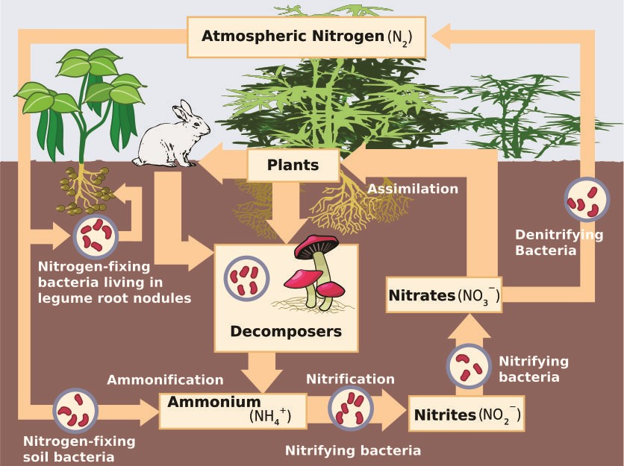

### Physical Process

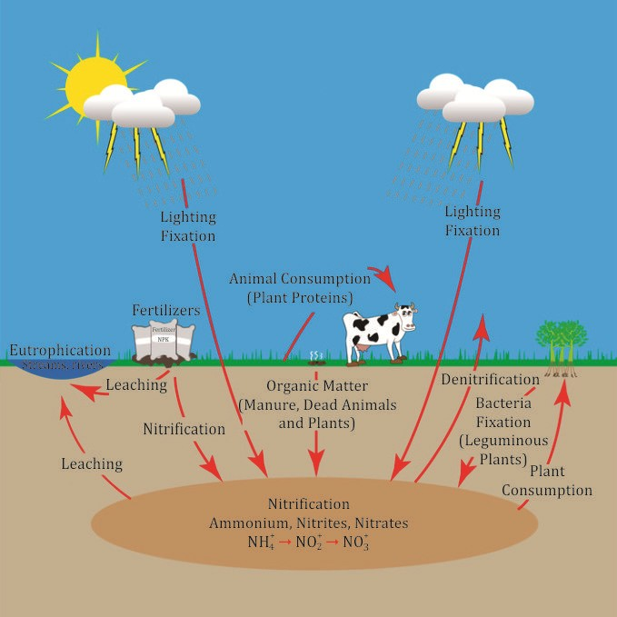

* During lightning, atmospheric nitrogen reacts with oxygen and forms dilute nitric acid.
* This nitric acid comes down to the Earth during rainfall.
* Plants use nitric acid to form nitrates, which are further used to synthesise proteins.
* When plants and animals die or when animals excrete urea and uric acid, certain bacteria carry out ammonification.
* Plants can assimilate these ammonium ions, or bacteria further convert them into nitrate ions by nitrification.
* Some bacteria, such as pseudomonas, convert nitrates into nitrogen, ammonia or oxides of nitrogen. This process is called denitrification.
* Free nitrogen is released in the atmosphere, while oxides are used up by plants.

### Carbon Cycle

* Carbon is an important constituent found in all living organisms in the form of carbohydrates, proteins, fats and nucleic acids.
* Carbon dioxide is used by plants for photosynthesis.
* It is released by living organisms during respiration.
* It is also released during the burning of fossil fuels and volcanic eruptions.

### Oxygen Cycle

* Oxygen constitutes about 21% of the total atmosphere.
* Living organisms require oxygen for respiration.
* During photosynthesis, oxygen is released in the atmosphere.
* Oxygen is also released during the process of decomposition of dead matter by bacteria.
* It is also present in the form of ozone in the atmosphere.
* Ozone absorbs the harmful ultraviolet radiations from the Sun and protects life on Earth.